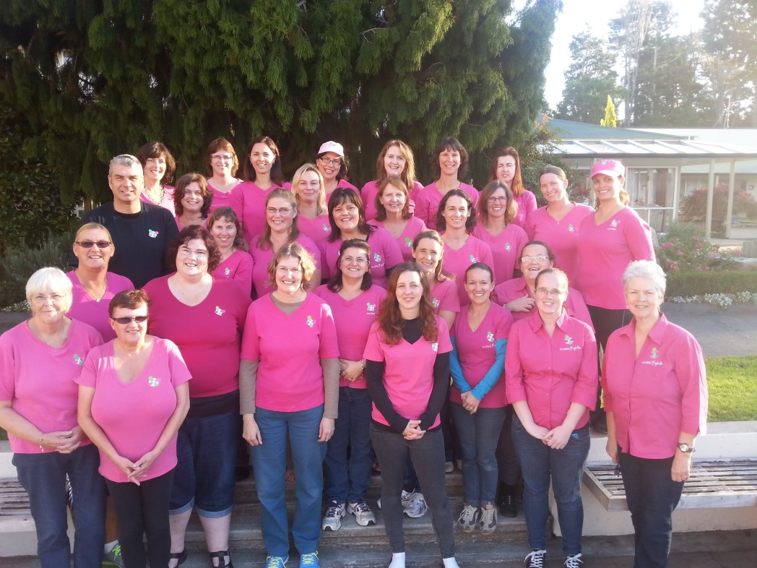

Leaders at Totara Springs Training Weekend
iconz4girlz Annual Report 2014
The iconz4girlz network continued its steady growth in 2014 with 5 more Units launching. We ended the year with a total of 23 Units.
A major review of uniforms and badges was undertaken as we looked at suitability, serviceability, supply and cost. The whole IFG shop was then outsourced to Seeit with leaders having the convenience of ordering their requirements from their own online Corporate Page.
A training weekend for leaders was held at Totara Springs in Matamata in May where the leaders enjoyed getting to know each other while keeping busy with a full weekend of activities and learning.
Chris was then able to visit all but two of the Units who did not have leaders at the training weekend to present an overview of the course content.
Filming of the “indoors” segments for our promotional DVD was completed and, with just the final tweaking to do, this should be available early in 2015.
Leaders were kept informed throughout the year with regular issues of the i-girlz enewz. Enquires via the website increased during 2014 and the use of Facebook as a medium to connect leaders and promote i-girlz was continued to be encouraged.
At their meeting in November the GBNZ Board approved the appointment of Isabel Ross to the National Management Team as the i-girlz leaders’ representative. There is still another vacancy on the team.
As always we are indebted to all the people who share our vision for this ministry to girls. To leaders, supporters and sponsors please accept this as a personal acknowledgement for the positive influence you have made in our communities by being involved with the i-girlz programme.

National Ministry Team Members
Christine Brunt (Convenor)
Jennifer Box JP QSM
Charmayne Johnstone
Isabel Ross (Leaders’ Representative)
Janice Zachan JP QSM (Associate Member)
Stu Thompson BB ICONZ (Consultant and Trainer)

